Factor Analysis

Notes
Output Created |  | 28-JUN-2021 14:38:16
Comments
Input | Data | /Users/coderlax/Desktop/EO Hackathon/Asia/Social Mobility/Z score/Z3.sav
Input | Active Dataset | DataSet11
Input | Filter | <none>
Input | Weight | <none>
Input | Split File | <none>
Input | N of Rows in Working Data File | 86
Missing Value Handling | Definition of Missing | MISSING=EXCLUDE: User-defined missing values are treated as missing.
Missing Value Handling | Cases Used | LISTWISE: Statistics are based on cases with no missing values for any variable used.
Syntax |  | FACTOR  /VARIABLES ZGrocery ZTransit ZResidental  /MISSING LISTWISE  /ANALYSIS ZGrocery ZTransit ZResidental  /PRINT UNIVARIATE INITIAL CORRELATION KMO EXTRACTION ROTATION  /FORMAT SORT  /PLOT EIGEN  /CRITERIA FACTORS(3) ITERATE(25)  /EXTRACTION PC  /CRITERIA ITERATE(25)  /ROTATION VARIMAX  /METHOD=COVARIANCE.
Resources | Processor Time | 00:00:00.16
Resources | Elapsed Time | 00:00:00.00
Resources | Maximum Memory Required | 1984 (1.938K) bytes

Descriptive Statistics
 | Mean | Std. Deviation | Analysis N
ZGrocery | 2.2524292 | .99999976 | 86
ZTransit | 1.0909097 | 1.00000041 | 86
ZResidental | 1.8796301 | .99999965 | 86

Correlation Matrix
 |  | ZGrocery | ZTransit | ZResidental
Correlation | ZGrocery | 1.000 | .840 | -.750
Correlation | ZTransit | .840 | 1.000 | -.949
Correlation | ZResidental | -.750 | -.949 | 1.000

KMO and Bartlett's Testª
Kaiser-Meyer-Olkin Measure of Sampling Adequacy. |  | .634
Bartlett's Test of Sphericity | Approx. Chi-Square | 300.958
Bartlett's Test of Sphericity | df | 3
Bartlett's Test of Sphericity | Sig. | <.001

a. Based on correlations

Communalities
 | Raw |  | Rescaled
 | Initial | Extraction | Initial | Extraction
ZGrocery | 1.000 | 1.000 | 1.000 | 1.000
ZTransit | 1.000 | 1.000 | 1.000 | 1.000
ZResidental | 1.000 | 1.000 | 1.000 | 1.000

Extraction Method: Principal Component Analysis.

Total Variance Explained
 | Component | Initial Eigenvaluesª |  |  | Extraction Sums of Squared Loadings
 | Component | Total | % of Variance | Cumulative % | Total | % of Variance | Cumulative %
Raw | 1 | 2.695 | 89.843 | 89.843 | 2.695 | 89.843 | 89.843
Raw | 2 | .268 | 8.917 | 98.760 | .268 | 8.917 | 98.760
Raw | 3 | .037 | 1.240 | 100.000 | .037 | 1.240 | 100.000
Rescaled | 1 | 2.695 | 89.843 | 89.843 | 2.695 | 89.843 | 89.843
Rescaled | 2 | .268 | 8.917 | 98.760 | .268 | 8.917 | 98.760
Rescaled | 3 | .037 | 1.240 | 100.000 | .037 | 1.240 | 100.000

Total Variance Explained
 | Component | Rotation Sums of Squared Loadings
 | Component | Total | % of Variance | Cumulative %
Raw | 1 | 1.664 | 55.463 | 55.463
Raw | 2 | 1.256 | 41.876 | 97.339
Raw | 3 | .080 | 2.661 | 100.000
Rescaled | 1 | 1.664 | 55.463 | 55.463
Rescaled | 2 | 1.256 | 41.876 | 97.339
Rescaled | 3 | .080 | 2.661 | 100.000

Extraction Method: Principal Component Analysis.
a. When analyzing a covariance matrix, the initial eigenvalues are the same across the raw and rescaled solution.

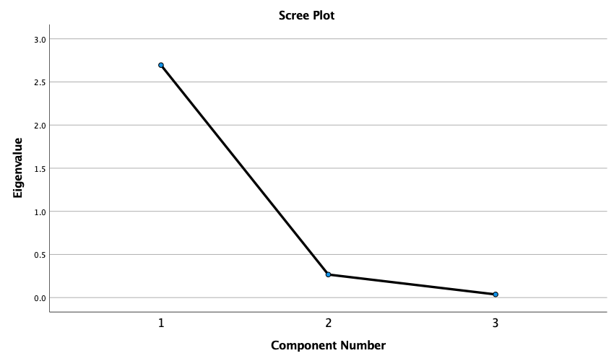

Component Matrixª
 | Raw |  |  | Rescaled
 | Component |  |  | Component
 | 1 | 2 | 3 | 1 | 2 | 3
ZTransit | .983 | -.110 | .149 | .983 | -.110 | .149
ZResidental | -.952 | .285 | .116 | -.952 | .285 | .116
ZGrocery | .908 | .418 | -.040 | .908 | .418 | -.040

Extraction Method: Principal Component Analysis.ª
a. 3 components extracted.

Rotated Component Matrixª
 | Raw |  |  | Rescaled
 | Component |  |  | Component
 | 1 | 2 | 3 | 1 | 2 | 3
ZResidental | -.917 | -.398 | -.007 | -.917 | -.398 | -.007
ZTransit | .802 | .532 | .273 | .802 | .532 | .273
ZGrocery | .425 | .902 | .073 | .425 | .902 | .073

Extraction Method: Principal Component Analysis.
Rotation Method: Varimax with Kaiser Normalization.ª
a. Rotation converged in 4 iterations.

Component Transformation Matrix
Component | 1 | 2 | 3
1 | .759 | .639 | .127
2 | -.643 | .766 | -.007
3 | -.101 | -.076 | .992

Extraction Method: Principal Component Analysis.
Rotation Method: Varimax with Kaiser Normalization.

